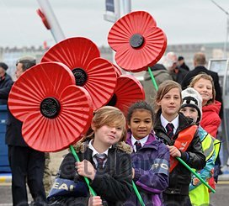
Children and the Legion :

An urgent appeal to members

Your Paris branch has been invited into a number of schools in the Paris/Ile de France area to speak about our association, its work and poppies. As part of our schools Remembrance Project this year we have also received requests for veteran members to visit schools to answer questions from students about military service and memories.

If you have served in the forces at any time or have childhood wartime memories and would like to share your experiences with youngsters, talk about it for a few minutes or maybe just offer to answer questions we would very much appreciate your participation.

The following dates are already fixed.
- The British School of Paris, Juniors on Tuesday afternoon 13th October and Thursday afternoon 15th October.

- Lycée Rabelais in Meudon on Monday 2nd November,

- Lycée Descartes in Montigny les Bretonneux Friday 20th November

Janet Hadley can collect you and take you by car to and from the venue. Questions will be in English.

Alternatively, if you know anyone, not necessarily a Legion member, who might be interested in participating and whom we could approach, please don't hesitate to let us know.
If members, or friends, prefer not to visit schools, we are also looking at the possibilities such as a Skype interview at the Clubhouse and making written responses to questions sent in by students. We will be very grateful for any contributions, suggestions and assistance with this project from members and their contacts.

Please contact Janet (hadley.janet@gmail.com or by phone 06 24 59 74 31) if you are willing and able to participate, either on one of the above dates or in the future. We have already received much positive feedback about our project with schools. The experience is sure to be rewarding for all.

